**Planning Documentation**

Vehicle Rental System Project

**1. Introduction**

The **Vehicle Rental System** is a basic project aimed at helping beginners practice Java programming by developing a minimalistic system to list vehicles and allow customers to search for and view details about vehicles. The project is planned as a 2-day task focusing on core Java and Object-Oriented Programming (OOP) concepts. This document outlines the planning phase of the project to provide a reference for stakeholders and guide development.

**2. Project Objectives**

The key objectives of the Simple Vehicle Rental System are:

1. **For Customers**:
   * View a list of vehicles available in the system.
   * Search vehicles based on basic criteria like make, model, and price range.
2. **For the System**:
   * Use OOP concepts in Java to represent vehicles, users, and other core components.
   * Implement a simple console-based interface for interacting with the system.

**3. Scope of the Project**

The scope of the Simple Vehicle Rental System includes the following basic functionalities:

* **Vehicle Class**: Create a Vehicle class with attributes like make, model, price, and year.
* **Inventory Management**: Store vehicle data using a simple collection (e.g., ArrayList) to manage vehicles in memory.
* **Search Feature**: Implement basic searching functionality for users to find vehicles based on make or price range.
* **Console Interface**: Provide a text-based interface where users can view the available vehicles and search for specific ones.

**4. Stakeholders**

The stakeholders for this project include:

* **Beginner Developers**: Those using this project as a learning task to practice Java.
* **Mentors/Reviewers**: Individuals who will review the completed project for feedback and improvements.

**5. Project Timeline and Milestones**

Given that this is a small project for beginners, the timeline is set for 2 days with the following milestones:

1. **Day 1: Setup and Core Development**
   * Create the basic structure of the project, including package setup and class creation (e.g., Vehicle, Inventory, and Main class).
   * Implement the Vehicle class with relevant attributes and methods (e.g., getters and setters).
   * Develop the inventory management functionality, including adding vehicles and listing all available vehicles.

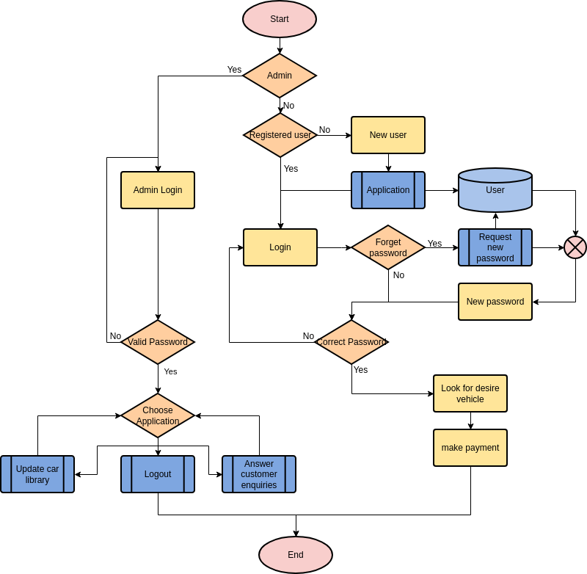

1. **Day 2: Search Functionality and Console Interaction**
   * Implement the search feature to allow users to filter vehicles by make and price range.
   * Develop the console-based user interface for interacting with the system (e.g., display available options, take user input).
   * Conduct basic testing to ensure all functionalities work as expected.

**6. Resource Planning**

As a beginner project, the resources needed are minimal:

* **Development Environment**: A Java IDE like IntelliJ IDEA, Eclipse, or NetBeans.
* **Java JDK**: Java Development Kit to compile and run the Java code.
* **Basic Knowledge of Java**: Familiarity with classes, objects, methods, and basic input/output operations in Java.

**7. Risk Management**

Some potential risks and mitigation strategies for this simple project:

* **Risk 1: Errors in Implementation of OOP Concepts**
  + Mitigation: Beginners should refer to documentation or tutorials on OOP principles and get feedback from mentors.
* **Risk 2: Difficulty with Java Syntax or Errors**
  + Mitigation: Use an IDE with built-in error checking and debugging tools to quickly identify and resolve issues.

**8. Deliverables**

The deliverables for this project are:

1. **Source Code**: The complete Java code for the Vehicle Rental System, including the Vehicle, Inventory, and Main classes.
2. **User Manual**: A short document explaining how to run the program, what functionalities it includes, and how to interact with the console interface.

**9. Conclusion**

This project provides a hands-on exercise for beginners to practice Java development, focusing on core concepts like OOP and simple data management. With a focus on building a functional console-based system in 2 days, it will help learners understand key Java principles while building a simple vehicle Rental application.